Name: ___________________________________________________ Date: _____________________

AP Calculus AB: Unit 7 Day 1 HW Visca

In Exercises 1–8, the function *v*(*t*) is the velocity in m/sec of a particle moving along the *x*-axis. Use analytic methods to do each of the following:

**(a)** Determine when the particle is moving to the right, to the left, and stopped.

**(b)** Find the particle’s displacement for the given time interval. If *s*(0) = 3, what is the particle’s final position?

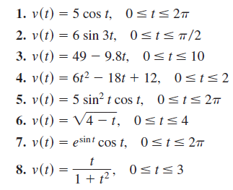

**29.** *Hooke’s Law* A certain spring requires a force of 6 N to stretch it 3 cm beyond its natural length.

**(a)** What force would be required to stretch the string 9 cm beyond its natural length?

**(b)** What would be the work done in stretching the string 9 cm beyond its natural length?

**30.** *Hooke’s Law* Hooke’s Law also applies to *compressing* springs; that is, it requires a force of *kx* to compress a spring a distance *x* from its natural length. Suppose a 10,000-lb force compressed a spring from its natural length of 12 inches to a length of 11 inches.

How much work was done in compressing the spring

**(a)** the first half-inch?

**(b)** the second half-inch?